Neighboorhood Plan News 6 July 2026

Go-ahead given for Neighbourhood Planning to start

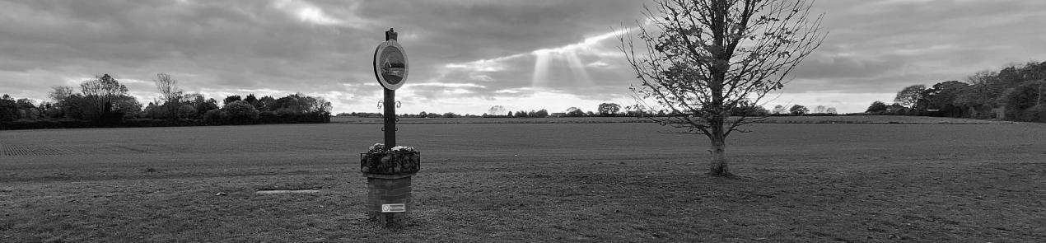

At the July meeting of the Wicklewood Parish Council it was decided to kick-start the process of developing a neighbourhood plan for the village. This followed an opinion poll conducted online and on paper at the Cherry Tree pub and three public meetings in June at the village hall to gauge the level of support for the idea of a plan.

There were 54 replies to the opinion poll. This is more than 10% of the households in the village, which is a good response rate for a survey like this. All but one said it would be worthwhile to have a neighbourhood plan. Most of those who replied (45) welcomed the chance to share ideas about future development plans in Wicklewood and nearly a quarter (12) said they would like to join a group to help develop a plan. Additionally, more than half (30) said they might be interested in joining the group.

This very positive response was reflected in the public meetings, attended by over 60 villagers. A range of concerns and aspirations were aired at the meetings such as more footpaths around the village, more affordable housing, better facilities including re-opening of a village shop, more school places, preservation of our dark night skies, more of a say in the numbers and types of housing built in the village, reduction of traffic speeding and preservation of the rural character of the village. Nearly two-thirds of those attending the meetings said they would like to get involved in developing the plan in some way.

What the Parish Council is going to do next
- Form a small temporary steering group to start the process of applying for a grant from South Norfolk District Council to help fund the planning process.
- Investigate the appointment of a suitably experienced consultant to help with the planning process.
- Start a newsletter. The newsletter will be emailed to everyone who has given us their contact details. It will also be on the Parish Council Web site.
- Follow up on expressions of interest to recruit a wider range of steering group members that more accurately reflects the composition and interests of the village.

What you can do next:
- Let us know if you want to receive the newsletter, by emailing the parish clerk clerk@wicklewoodpc.norfolkparishes.gov.uk, with “Neighbourhood Plan” in the subject line.
- Let us know if you would like to join the steering group or help with gathering information and opinions. We need a good range of ages, interests and experiences to fully represent the village.
- Tell your neighbours and friends in the village about it and how they can join.

The more volunteers there are, the less work there will be to do for each of us, but no-one will be pressurised into volunteering for anything. All contact details sent to clerk@wicklewoodpc.norfolkparishes.gov.uk will be stored securely and not released to any other parties.

