Wicklewood Neighbourhood Plan Takes Its First Steps
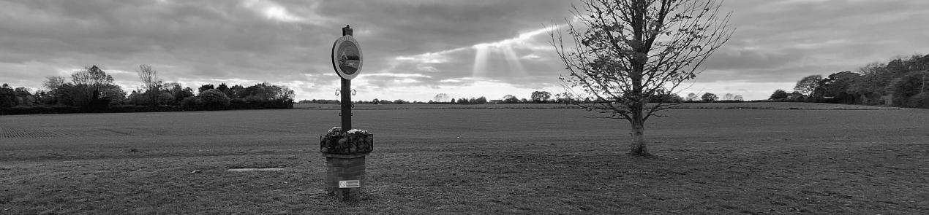
Plans to develop a Neighbourhood Plan for Wicklewood are moving forward, with a Steering Group now established and preparations beginning for wider community involvement.
The group met at Wicklewood Village Hall on 18 August and agreed its terms of reference, with Stephen Brown appointed Chair, Ralph Withers Vice-Chair and Heather Wrighthardt Secretary. The group will report progress to the Parish Council after each meeting and will meet monthly, on the third Tuesday of the month.
The Parish Council has formally notified South Norfolk District Council of its intention to develop a Wicklewood Neighbourhood Plan covering the parish of Wicklewood and Crownthorpe. Funding is also being investigated, although the Steering Group agreed that it is too early to apply for grants while the plan's objectives are still being developed.
One of the group's priorities is finding better ways to involve residents. At present, information is shared through the parish website, noticeboard, Net magazine and a small email list, but the group recognises that these methods do not reach everyone in the village.
Plans are therefore being developed for a community engagement event, while other ideas include a dedicated Facebook page, using the Wicklefolk Facebook page and Wymondham Magazine, improving the parish noticeboard and delivering information to households.
The group will also seek advice from the Campaign to Protect Rural England (CPRE), while research into other village plans, including Reedham's, will help inform Wicklewood's approach.
There are also some early plans to give the project a distinctly Wicklewood identity. The group has agreed that the village windmill should inspire the Neighbourhood Plan logo and is working towards a short mission statement capturing what the plan aims to achieve.
The next Steering Group meeting will take place on 15 September at 7pm, with further meetings scheduled for 20 October, 17 November and 15 December.
Please pass on this news to your neighbours and tell them they can sign up for the Neighbourhood Plan newsletter by emailing clerk@wicklewoodpc.norfolkparishes.gov.uk

