Norfolk County Council proposes to make a Temporary Traffic Regulation Order (the “Order”) (STRO14383) affecting the U78214 Top Road from its junction with U48068 The Green for 30 metres southwards (the “Road”) in the Parish of Wicklewood to facilitate patching works, the Road will be temporarily closed (except for pedestrian access) for the duration of the works/period the closure is necessary which is anticipated to be from 20th to 22nd April 2026, but may continue to be closed/restricted until the 3rd June 2026 where the closure is still required beyond the anticipated dates.

Alternative route is via: Top Road, The Green, Hospital Road, Wymondham Road, Hackford Road, Milestone Lane.

The works promoter for this restriction/closure is: Norfolk County Council.

Vehicular access will be permitted to a final destination in the Road where signs indicating such access is possible and permitted are in place.

The Order shall automatically revoke on the completion of the works when the closure is no longer necessary or otherwise on the 3rd June 2026 without further notice.

If necessary, the restriction could run for a maximum period of 18 months from the date the Order is effective.

A person who contravenes, or who uses or permits the use of a vehicle in contravention of the closure imposed by the Order shall be guilty of an offence.

Penalty: £1000 maximum fine on conviction and/or endorsement for contravention.

In the event of the start date being delayed the new start date will be displayed on site in advance.

Full details on the closure are available at https://one.network. Any enquiries that cannot be answered on the one.network website should be directed to the South Area Streetworks (Infrastructure Department) contactable by telephone at 0344 800 8020 or email at streetworks@norfolk.gov.uk

Dated this 10th day of April 2026.

Katrina Hulatt
Director of Legal Services (nplaw)
County Hall
Martineau Lane
Norwich
NR1 2DH

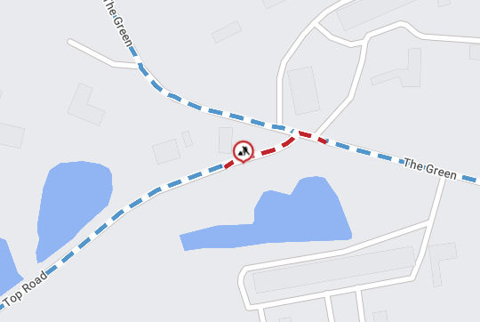

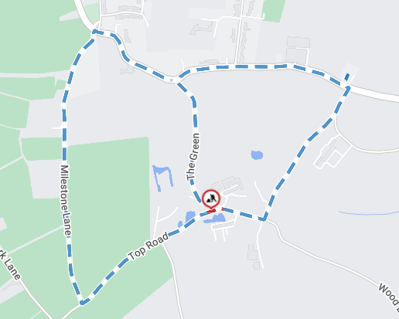

Imagery © 2026 MapTiler | Imagery © 2026 Hexagon | © MapTiler © OpenStreetMap contributors

