NORFOLK COUNTY COUNCIL has made a Temporary Traffic Order affecting the U78209 High Street from its junction with U78064 Low Street, for 109 metres northwards in the PARISH OF WICKLEWOOD because of new sewer connection works.

The road will be temporarily closed (except for access) from 15th March 2021 to 19th March 2021 for the duration of the works, expected to be 5 days within the period.

Alternative route is via: High Street, Wicklewood Road, Wymondham Road, Station Road, Hingham Road, Low Road, Hackford Road (Deopham, Kimberley, Wicklewood)

(If necessary the restriction could run for a maximum period of 18 months from the date of the Order).

Penalty: £1000 maximum fine on conviction and/or endorsement for contravention.

In the event of the start date being delayed the new start date will be displayed on site in advance.

The person dealing with enquiries at Norfolk County Council is Adam Mayo (Community and Environmental Services) Telephone 0344 800 8020.

Dated this 12th day of March 2021

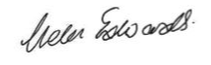

Helen Edwards
Chief Legal Officer

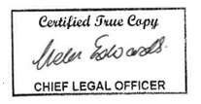

County Hall
Martineau Lane
Norwich
NR1 2DH



